Generative AI HW4 電機四 4111064113 白舜文
I . Problem Description
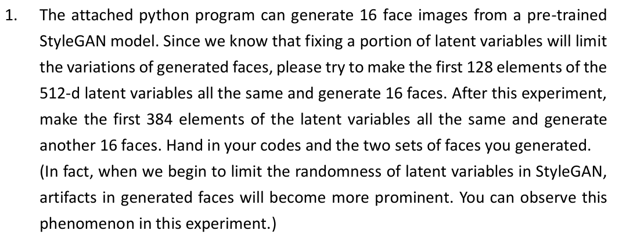
II. StyleGAN results
fixed_128.png:
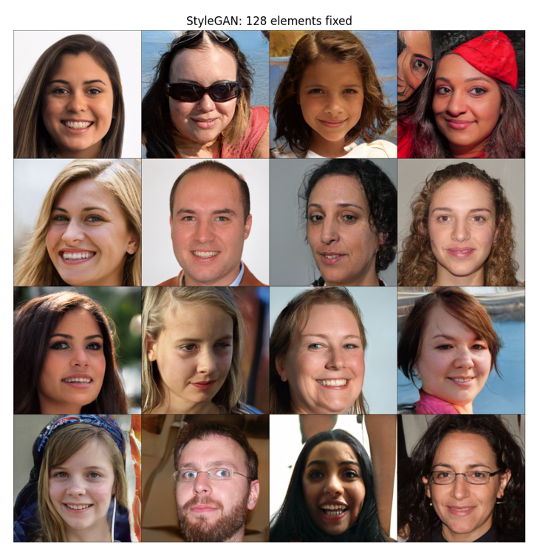

fixed_384.png:
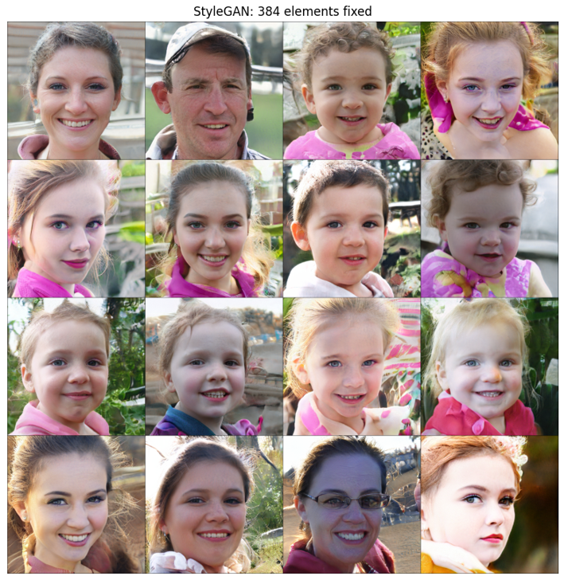

根據上面兩種實驗可知，透過潛在變數的改變，並限制其隨機性，可對於影像生成的品質進行初步的探討：
1. 在固定前128維潛在變數下，人臉依然保持著高度的多樣性，包含配件、膚色、髮型等等特徵，整體的相似度不高，圖像也較為自然。
2. 接著限制到384維潛在變數，可觀察到整體的相似性提高許多，包含臉部角度、臉型特徵、衣服顏色等等。此時僅剩128維在控制細節導致變異性降低，同時也可觀察到圖像中的Artifacts(圖形的偽影、瑕疵)也變多了，在影像邊緣的雜訊斑點變多，頭髮的銜接處也明顯的不自然。

III. Source code
import torch
from matplotlib import pyplot
import torchvision
model = torch.hub.load('ndahlquist/pytorch-hub-stylegan:0.0.1', 'style_gan', pretrained=True)
# %matplotlib inline
model.eval()
device = 'cuda:0' if torch.cuda.is_available() else 'cpu'
model.to(device)
def stylegan_experiment(fix_dim, save_name):
nb_rows = 4
nb_cols = 4
nb_samples = nb_rows * nb_cols
latents = torch.randn(nb_samples, 512, device=device)
# replace the fix_dim elements in 1~15 samples with element corresponding to the 0 sample
if fix_dim > 0:
latents[1:, :fix_dim] = latents[0, :fix_dim].clone()
with torch.no_grad():
imgs = model(latents)
# normalization to 0..1 range
imgs = (imgs.clamp(-1, 1) + 1) / 2.0
imgs = imgs.cpu()
grid_img = torchvision.utils.make_grid(imgs, nrow=nb_cols)
pyplot.figure(figsize=(10, 10))
pyplot.imshow(grid_img.permute(1, 2, 0).detach().numpy())
pyplot.title(f"StyleGAN: {fix_dim} elements fixed")
pyplot.axis('off')
pyplot.savefig(save_name)
# Experiment 1: first 128 elements remain same
print("Experiment 1 executed: fixed_128 elements")
stylegan_experiment(128, "fixed_128.png")
# Experiment 2: first 384 elements remain same
print("Experiment 2 executed: fixed 384 elements")
stylegan_experiment(384, "fixed_384.png")
pyplot.show()

